Response to the reviewers

We thank the reviewers for their time and effort. We have taken care to address all of their comments, as well as provide additional edits. We believe that the paper has been improved in clarity and quality due to their feedback. All revisions are listed below, following the corresponding original comment from the reviewers.

Reviewer #1: The work in consideration studies defect-GB interaction and GB diffusion using classic molecular dynamics simulations. A set of data including defect segregation energies, defect-GB interaction distance and defect and self- diffusivities in GBs are reported. The Coble creep rate is also computed using the GB diffusivities. These data are useful for understanding irradiation behavior in alpha-U and for continuum scale modeling. Overall, the work is carried out rigorously and suitable for JNM. Meanwhile, I also have a few comments and suggestions for the authors to consider.

1. The authors are suggested to clarify the GB notation. Since [100], [010] and [001] are not symmetrical in alpha-U, square brackets, [, are more appropriate for the tilt axes than chevrons, which are usually used for families of symmetrical orientations. Also, what is shear plane? Usually, the tilt axis is contained in the GB plane. Following this, shouldn't the tilt axis be [001] as the GB planes are (-3 12 0) and (-12 3 0)? Similarly, the tilt axes should be [0 1 0] and [1 0 0] for type B and C? Some clarification is needed. Providing a schematic figure will be helpful.

For the GB notation, we have followed the nomenclature from [K. Mahbuba, B. Beeler, and A. Jokisaari, “Evaluation of anisotropic grain boundaries and surfaces of 𝛼-U via molecular dynamics,” Journal of Nuclear Materials, vol. 554, p. 153072, 2021]. In that respective article, the tilt axis is the intersection between the GB plane and the shear plane. This has been emphasized in the present article.

2. In section 3.2.1, it's shown that V diffusion is 2D in the A1, B1 and C1 GBs. This is very surprising because A1 and C1 GBs are shown to have zero interaction with vacancy (see figure 4). The negligible segregation energy implies vacancies are not trapped by them and expected to perform 3D diffusion. The authors are suggested to provide further clarifications of these results.

Here the diffusion is the diffusion of the GB in the presence of the vacancy. GB diffusion is typically 2D along the GB planes. For reference, the authors have attached the trajectory lines for the atoms within the GB volume for A1, B1, and C1 GBs. Vacancies have been inserted to initiate diffusional processes in these GBs. While the binding energy is statistically insignificant, it may be sufficient to maintain the vacancy in the GB, or the migration pathways are sufficiently lower in the GB plane that the vacancy jumping into the bulk is effectively an unlikely process. This statement has been included in the manuscript. Figures indicating representative diffusion pathways via trajectory lines are now included in the appendix to supplement the descriptions in section 3.2.

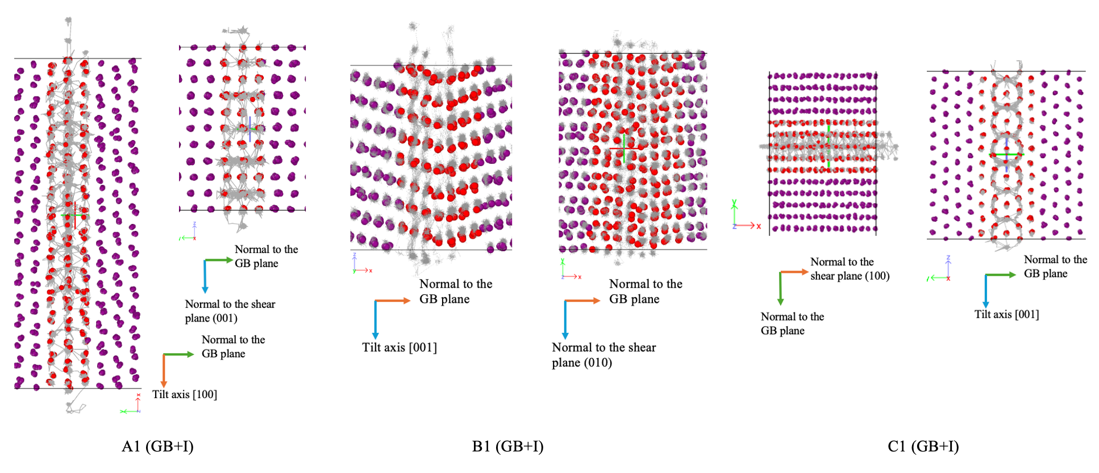

Figure: Trajectory line (gray lines) of the atoms within the simulation time period. Atoms with red color are the atoms that are considered during the MSD calculation. Both red and purple atoms are alpha-U atoms.

3. In figure 7(b), low energy type B GBs (dashed curves) are shown to have larger interaction distances than high energy type B GBs. This is surprising and different than type A & C GBs. Please explain why.

We agree that this is surprising. We would argue that these interaction lengths are comparable, and the differences may not be statistically significant. If we look at figure 2b, the error bars for segregation energies are sufficiently large to complicate the identification of the interaction length for the type B GBs, whereas the transition is much clearer for type A and C. We defined a method for determining the IL, and utilized the same procedure for all GB types. It could be a peculiarity of these specific grain boundaries that we have minor stress fields induced in B1, but they are induced over a longer range. Sampling additional GB systems and types would allow one to identify if this phenomenon is indeed real and repeated for different GBs, or if this is an artifact of the way that GB ILs are determined within this work. There is no known reason why the type B GBs would behave differently than the type A or type C, other than their orientation.

4. In figure 3 (b) and (c), the vacancy formation energy in type B GBs is systematically higher than in bulk, although still within error bar. Is this from the simulation cell size effect?

This is potentially due to simulation cell size effects. This may also be due to slight changes in the reference state, as GBs are metastable systems, and with unique initial velocity distributions, they may converge to different energy values. However, as the error bars overlap, such a minor discrepancy does not change any of the analyses or conclusions presented in this work.

5. In section 3.2.1, the sentence "The self-diffusion of GB+V and GB+I of A1 and B1 GBs tend to converge as the temperature increases, while self-diffusivity for the lowest formation energy GB considered in the current work, C1, maintains an approximately constant ratio (2.2 to 2.5) between the two defect cases" is not very clear. Did the authors mean GB+V and GB+I approach each other at high temperatures for A1 and B1? Please rephrase the text to make the point clear.

Thank you for the question. Yes, the authors meant that the GB+V and GB+I approach each other at high temperatures for A1 and B1. Additional clarifying text has been added.

6. In section 3.2.2, there are some interesting discussions on the actual diffusion paths in different GBs. However, the descriptions are not very easy to follow. Can the authors show the diffusion paths in figures with the GB planes and tilt axes labelled?

These figures are now included in the appendix. The trajectories for type X1 GBs were shown in response to question #2, and for type X2, they are shown below. All six figures are present in the updated appendix.

7. In figure 11, how is the self-diffusion computed? It might not be a fair comparison between GB+V (and GB+I) and self-diffusion in bulk. With extra defects added, what are computed are actually defect diffusivity in GBs, not self-diffusion in GBs. Please clarify. because for low energy GBs, the computed self-diffusivity is actually defect-diffusivity in those GBs, not self-diffusivity.

We agree that the comparison is not exact. Since diffusion does not occur naturally in these very clean GBs, their diffusion would be zero. We are trying to determine something closer to the real-world scenario by including defects and analyzing diffusion in a consistent manner. The other grain boundaries can be considered to already have ‘defects’, occurring naturally from the lattice misorientation. However, we are not computing the defect diffusivity itself, but determining the GB diffusivity in the presence of a defect. The defect diffusivity inside the GB would be significantly higher (MSD of all atoms times the number of atoms = total squared displacement of the defect).

8. In section 3.2.2, what's the motivation for calculating the weighted average of GB diffusivity? Note that the diffusivities in different GBs can vary by several orders of magnitude. A weighted average may not be a proper way of comparing diffusivities in different tilt GBs.

The motivation behind using the weighted average method is to try to perform a normalization for GB energy, in the hopes of determining an approximate value given a distribution of GB energies that are present within the system. This method should be more robust than simple averaging, specifically because of the small sample size of GB types explored. Ideally, many GB systems would be explored to improve the averaging behavior.

9. Similarly, can the authors give more discussion on the selection of diffusivity for computing the Coble creep rate? To avoid GB separation, diffusion needs to occur in all GBs to accommodate the change in grain shape. Saying that, the creep rate seems to be limited by the slowest GB diffusion rate, instead of average. This is only for the authors to consider as I am not a creep expert.

We appreciate the question and the point raised. There will be many GBs present within a real material, but all do not need to migrate for Coble creep to occur. Thus, we believe an average GB diffusivity is likely appropriate for this analysis, and is in accordance with prior simulation-based studies translating GB diffusion into Coble creep predictions [https://doi.org/10.1016/j.jnucmat.2021.153129, https://doi.org/10.2172/2315683].

Reviewer #2: The authors use molecular dynamics simulations to study the point defect interactions with grain boundaries and grain boundary self-diffusion in alpha U, which has a non-cubic crystal structure. They also use the calculated grain boundary diffusivities to estimate the coble creep rate. Overall, the manuscript is well written. However, there are some possible typos or errors in the manuscript. The authors must address them before the manuscript can be published.

1. Page 6, "a positive Es indicates an attraction". But according to Eq. (2) and also Figure 2, a negative Es means attraction. So a negative sign is needed in Eq. (2).

Thank you for pointing this out. We have corrected it.

2. Above Eq. (3), GB thickness (l_GB) doesn't appear in Eq. (3).

Sorry, this is a typo. GB thickness is denoted by in the rest of the article.

3. Page 8, I am not sure if the large error bar is due to the metastable nature of the GB. It could be that defects are trapped to different sites that have different energies.

Thank you for the suggestion. We agree and have added this note.

4. Figure 4 and possible other figures, I suggest including error bars if possible.

Thank you for the suggestion. We have included error bars where we felt it improved the clarity of the figures. We have not included error bars in all figures, but where error bars are excluded, the magnitude of the error has been indicated.

5. Eq. (5) emphasizes the contribution from high-energy GBs so that the weighted average is insensitive to GB type in Fig. 5. Is this a fair way to do the weighted average? The presence frequency of a GB may be inverse to its GB energy (not as the authors claimed). For example, the low-energy twin GB typically has a high presence frequency. The authors need to discuss about the physical meaning of their weighted average definition briefly.

The motivation behind using the weighted average method is to try to perform a normalization for GB energy, in the hopes of determining an approximate value given a distribution of GB energies that are present within the system. This method should be more robust than simple averaging, specifically because of the small sample size of GB types explored. Ideally, many GB systems would be explored to improve the averaging behavior.

For the specific formulation of the weighted average, the reviewer is correct, and the equations were initially intended to include the presence frequency, but an error was included and propagated, such that actually the frequency was not taken into account. This has been rectified in the equations and in the appropriate figures and discussion which reference this weighted average. We apologize for this error and we greatly appreciate the diligence of the reviewer.

6. Also in Eq. (5), Es,x,y can be confusing because here x means GB type A, B, C, but in Es,1,y it means GB 1 or 2.

Thank you for your suggestion. We have modified it to reduce confusion.

7. For some low-energy GBs, they do not have a significant segregation energy for vacancies or interstitials. When the authors put a point defect at these GBs, how can the authors know that these defects remain at the GBs during the diffusion calculation?

By tracing out the position of the atoms within the l_sb thickness, it has been verified that the defects have remained within the volume (GB area * l_sb). MSD is calculated for the atoms within this volume only. In the response to question 2 from reviewer 1, the trajectories are shown. We believe this is due to the reduced migration barrier for vacancies in the GB plane compared to the migration energies into the bulk. Thus, the vacancies are kinetically trapped once they reach the GB, despite the low segregation energies.

8. Some diffusivities seem to be different by a few orders of magnitude. I am not sure if there are some typos in the numerical values or in the units. For example, the fastest data in Fig. 10b is about 4E-14, but the rest in Fig. 9 and Fig. 10 are around 4E-6. In Fig. 11 and Fig. 12, the range changes again.

We apologize for utilizing inconsistent units, without changing the stated units. These figures have been rectified.

9. In Fig. 14, the (delta*D) value for alpha_U is even higher than the D value in Fig. 11 and Fig. 12. If delta is 1 nm, the (delta*D) should be around 1E-20 m3/s, right? The authors need to check the accuracy of their data and associated units carefully and thoroughly, including those shown in the Appendix.

We apologize again for utilizing inconsistent units and reporting those units incorrectly. This has been fixed.

10. A crystal structure of alpha U in the Appendix will be good to understand crystal orientations discussed in page 14.

Thank you for the suggestion. The unit cell of alpha U has been included in the appendix. The figure of trajectories has also been included in the appendix to provide an illustration for the discussion.

11. Figure 12, a few words are needed to describe about how the self-diffusivities in bulk alpha_U are calculated in Ref. 48.

Thanks for the suggestion, in Ref 48, the self-diffusivities in bulk alpha U are calculated using MD. This is now denoted both in the paragraph below the figure and in the caption.

12. Eq. (11) is misleading because the unit is not 1/s according to the equation. The authors may consider adding some units in the pre-factor to balance the units.

In this equation the stress is in MPa, temperature in K, and diameter in nm. So, the unit of the prefactor is (K-nm^3)/ (MPa-s). An indication of units has been included.